CSA0510 – DATABASE MANAGEMENT SYSTEM
LAB EXPERINMENT 8
Query with Sub Query& Correlated Query
AIM:
To perform subquery and correlated query on the given relations.
DESCRIPTION:
SUBQUERY
A MySQL subquery is a query nested within another query such as SELECT, INSERT, UPDATE or DELETE. In addition, a MySQL subquery can be nested inside another subquery.
A MySQL subquery is called an inner query while the query that contains the subquery is called an outer query. A subquery can be used anywhere that expression is used and must be closed in parentheses.
CORRELATED QUERY:
A correlated subquery is a subquery that uses the data from the outer query. In other words, a correlated subquery depends on the outer query. A correlated subquery is evaluated once for each row in the outer query.
SYNTAX:
SUBQUERY:
SELECTc1, c2,...,cn
FROMtable
WHEREc1 IN (SELECTc1, c2,...,cn
FROMtable
WHEREwhere_conditions);
CORRELATED QUERY:
SELECT*
FROMtable_name
WHEREEXISTS (subquery );

Questions:
Sub-Query and Correlated Sub-Query:
- Course Which of the student’s score is greater than the average score?
- Which of the students’ have written more than one assessment test?
- Which faculty has joined recently and when?
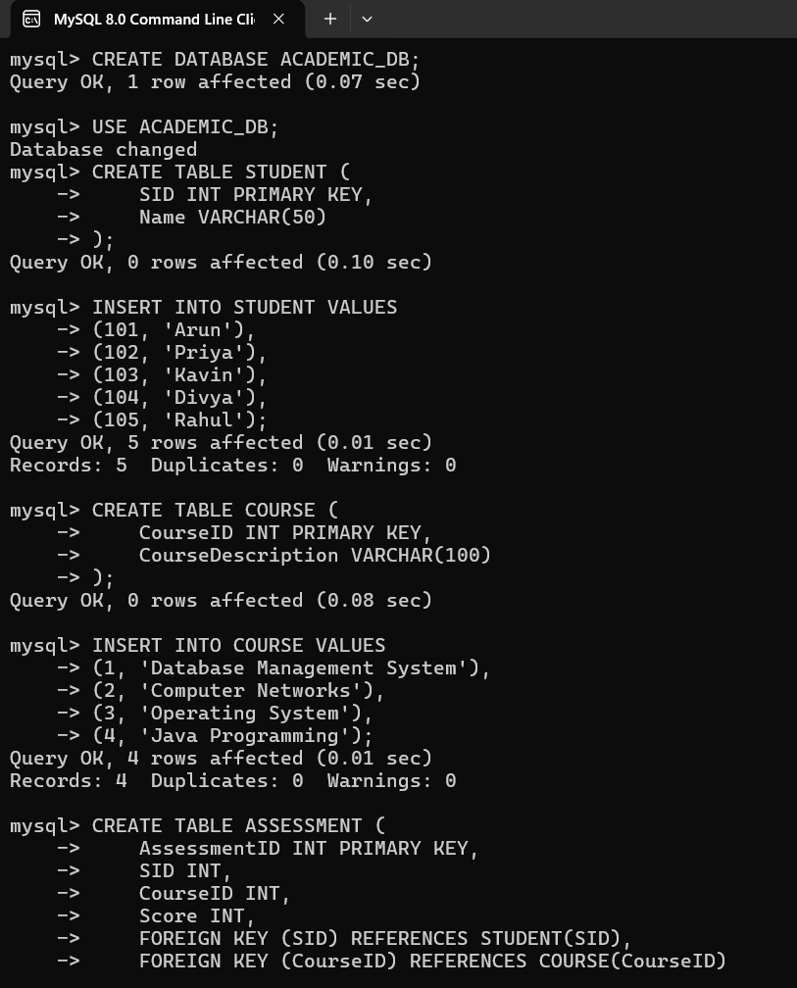
- List the course and score of assessments that have the value more than the average score each

